THINGS TO REMEMBER

You MUST personalize all these questions to your story. I have put in bold where there should be changes. If you have an antagonist, PLEASE add relevant questions in EVERY section.

There are SEVEN questionnaire sheets. You can, of course, change these around as much as you like. I broke my novel up into SIX chunks and created a question sheet with NO MORE THAN TEN questions per section.

The SEVENTH sheet is for the entire novel. All bets are off here, if you want to ask a million questions, do it. If your betas have gotten this far, they want to help. Ask away!

If you have any further questions, check out my YouTube video on beta readers, reach out via the comment section of that video, on Instagram, or the contact page on my website. Happy Writing!

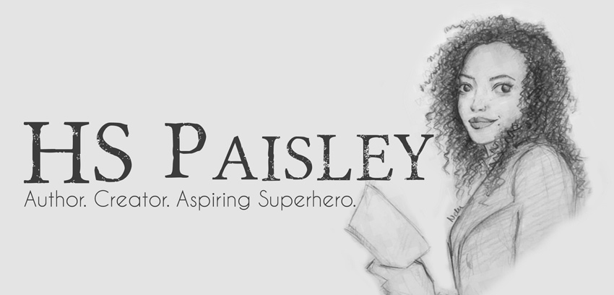
Beta Reader Feedback Sheet Chapters 1-3

- If you picked this up in a book story and read the first 3-5 pages, would you buy this book? If not, why?

- Did these chapters hold your interest from the very beginning? If not, why?

- What were your feelings towards ___main characters name___ in these chapters and if they changed, how so?

- Did the setting and the descriptions seem vivid and real to you?

- Were ___main characters name___ and ___ second main characters name___ believable? If not, what about them was not believable?

- Did the dialogue keep your interest and sound natural? If not, where did it sound artificial or not like that character would speak?

- Did you feel there was too much description or exposition? Not enough? Maybe too much dialogue in parts?

- Were there any scenes, lines, or paragraphs that you really liked?

- How does this compare to other _your genre_ you have read?

- What are your thoughts on ____put something specific about your story here____?

Beta Reader Feedback Sheet Chapters 4-6

- Did these chapters hold your interest? If not, why?

- Have your feelings towards ___main characters name___ changed? If yes, how so?

- What were your feelings towards ___ second main characters name___ in these chapters and if they changed, how so?

- Was there a point at which you felt the chapters lagged or you became less than excited about finding out what was going to happen next? Where, exactly?

- Were there any parts that confused you? Or even frustrated or annoyed you? Which parts, and why?

- Did you notice any discrepancies or inconsistencies in time sequences, places, character details, or other details?

- Did the dialogue keep your interest and sound natural? If not, where did it sound artificial or not like that character would speak?

- What was your favourite part of the first six chapters?

- What was your least favourite part of the first six chapters?

- Would you like the next chunk of chapters? If not, why? And either way, thank you so much for your feedback!

Beta Reader Feedback Sheet Chapters 7-10

- You are now one third of the way through the story. Where do you think it’s going? What are your expectations? What are you excited to see? Is there anything you hope does not happen? Please do not feel like you have to answer all these questions individually. They are prompts. I just want to know general thoughts.

- What were your feelings towards ___main characters name___ and ___ second main characters name___ ’s relationship? What do you like or dislike about it?

- Did these chapters hold your interest? If not, why?

- What were your thoughts on __secondary character’s name___ ? Did you like them? Dislike them? Why or why not?

- Have your feelings towards ___main characters name___ or ___ second main characters name___ changed? If yes, how so?

- Was there a point at which you felt the chapters lagged or you became less than excited about finding out what was going to happen next? Where, exactly?

- Are there any lines, paragraphs, or scenes that you really liked?

- If they have changed, what are your favourite and least favourite parts so far?

- Would you like the next chunk of chapters? If not, why? And either way, thank you so much for your feedback!

Beta Reader Feedback Sheet Chapters 11-16

- Have your feelings towards ___main characters name___ and ___ second main characters name___ ’s relationship changed? If so, how? What do you like or dislike about it?

- Did the setting and the descriptions seem vivid and real to you? If not, where did you feel they could be improved?

- How do you feel about the new characters introduced in these chapters? Do you have a favourite? Is there anyone in particular you’d like to learn more about? Do you think you know what they look like? Please do not feel like you have to answer all these questions individually. They are prompts. I just want to know general thoughts on the characters.

- Were there any scenes, lines, or paragraphs that you really liked?

- Was there a point at which you felt the chapters lagged or you became less than excited about finding out what was going to happen next? Where, exactly?

- Did you notice any discrepancies or inconsistencies in time sequences, places, character details, or other details?

- What are your thoughts on ____put something specific about your story here____?

- If they have changed, what are your favourite and least favourite parts so far?

- Would you like the next chunk of chapters? If not, why? And either way, thank you so much for your feedback!

Beta Reader Feedback Sheet Chapters 17-20

- How do you feel about the direction the story has gone? Do you like it? Dislike it? What did you like or dislike about it?

- Do you have any predictions of what you think might happen? Is there anything you hope do or does not happen?

- Over twenty chapters, ask a specific question about your story here.

- Was there a point at which you felt the chapters lagged or you became less than excited about finding out what was going to happen next? Where, exactly?

- Did you notice any discrepancies or inconsistencies in time sequences, places, character details, or other details?

- Were there any parts that confused you? Or even frustrated or annoyed you? Which parts, and why?

- Were ___main characters name___ and her friends believable? If not, what about them was not believable?

- Did you feel there was too much description or exposition? Not enough? Maybe too much dialogue in parts?

- Were there any scenes, lines, or paragraphs that you really liked?

- Would you like the next chunk of chapters? If not, why? And either way, thank you so much for your feedback!

Beta Reader Feedback Sheet Chapters 21-25

- How do you feel about the direction the story has gone? Do you like it? Dislike it? What did you like or dislike about it?

- Do you have any predictions of what you think might happen? Is there anything you hope do or does not happen?

- How do you feel about ask a specific question about your story here?

- Were there any parts that confused you? Or even frustrated or annoyed you? Which parts, and why?

- What are your general thoughts on the development of the side characters? If you have one, who is your favourite? Why? Question 8 is about _Secondary character of choice_, so if he’s your fav, you can just answer there.

- What are your thoughts or feelings on ___main characters name___ ?

- What are your thoughts or feelings on ___ second main characters name___ ?

- What are your thoughts or feelings on _Secondary character of choice?

- Would you like the next chunk of chapters? If not, why? And either way, thank you so much for your feedback!

Beta Reader Feedback Sheet Chapters 26-32

- How do you feel about the conclusion to this part of ___main characters name___ ’s story?

- How do you feel about _ask something specific to your story here?

- What are your general thoughts on __here is where I asked about things that were in the background of the story. Add something that works for you__?

- How do you feel about ___ second main characters name___ ’s actions in response to the decisions ___main characters name___ made?

- What are your general thoughts on _Secondary character_ through these last chapters?

- Was the final confrontation between ___ main characters name___ and ___main villain name___ believable? What about it made it believable or unbelievable?

Just one more sheet of questions!
There, you will find questions on the entire novel, not just these chapters.
Thank you so much for your help!
Beta Reader Feedback Sheet Final Thoughts
- How do you feel about the evolution of __main character___’s character throughout the novel?

- In a few words, or many if so you choose, please describe the physical attributes of the following characters

  - Character Name
  - Character Name
  - Character Name
  - Character Name
  - Character Name

- How do you feel about __something specific to your story here__? Did it add to the story? Take away from it?

- How did your thoughts, opinions, and feelings change about __main character___ throughout the novel?

- How did your thoughts, opinions, and feelings change about __ second main character___ throughout the novel?

- Did you have a favourite line, scene, paragraph? If so, what was it?

- How does this compare to other _your genre_ you have read?

- Would you read the next novel in the series? If not, why?

- Overall, what was the weakest part of the writing? And the weakest point in the story?

- Overall, what was the strongest part of the writing? And the strongest part of the story?

- Do you have any last general thoughts about the story?

THANK YOU SO MUCH FOR YOUR FEEDBACK!
You are all helping me make this story the best it can be!

